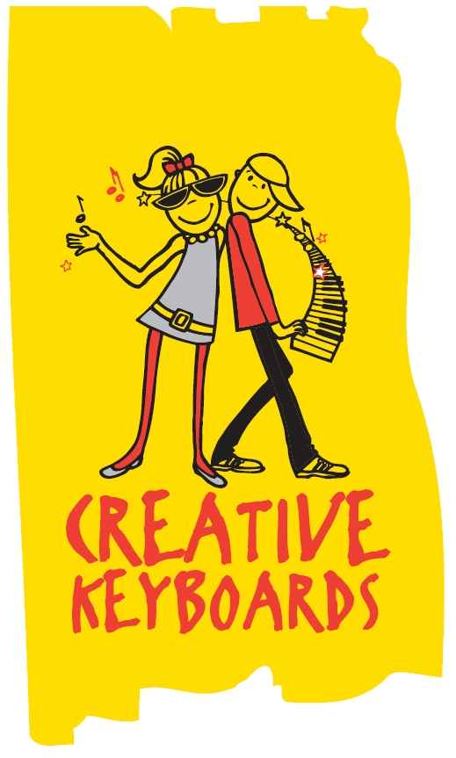

Creative Keyboards are delighted to be resuming classes in Douglas Rochestown ETNS

We are now enrolling for keyboard classes for September ‘23

Below are some details about the classes.

• Classes run from Thursday 14th September

• Fee €130 for 10 lessons.

• Keyboards and books are supplied for each pupil

• Students learn music from grade 1 to grade 8 level.

• A section of each class is dedicated to playing chart hits and favourite tunes.

Music magic course for infants which teaches reading,playng and singing

• Group classes according to age and standard.

• Recognised as a practical instrument for Junior and Leaving cert.

• We are certified by The Victoria College of Music London.

Jnr-Snr Infants: https://creative-keyboards.class4kids.ie/info/1897

Beginners: https://creative-keyboards.class4kids.ie/info/1898

Preliminary : https://creative-keyboards.class4kids.ie/info/1899

