Douglas Rochestown
Educate Together National School
Carr’s Hill, Douglas, Co. Cork, Roll Number: 20413N

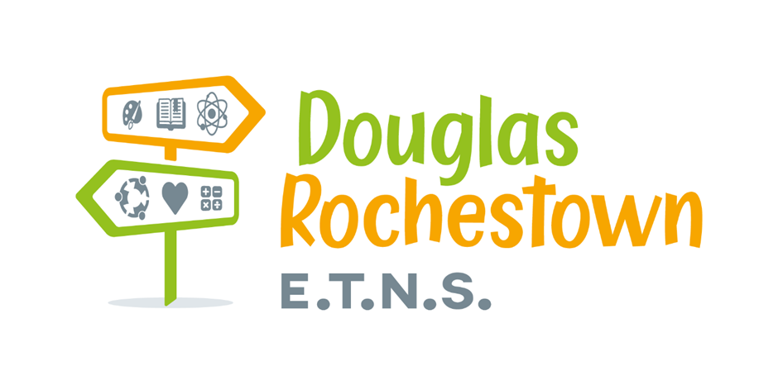

School Improvement Plan
Gaeilge 2022-2024

1. Introduction
1. Réamhrá
The focus of the evaluation
Fócas na Féinmheastóireachta
As part of our ongoing work in the school, we conducted a school self-evaluation of teaching and learning in 2023. We evaluated Gaeilge labhartha (Spoken Irish/Irish Oral Language). For more information on how the evaluation took place, please see our School Self-Evaluation Report which is available on our school website.
Mar chuid dár n-obair leanúnach sa scoil, rinnemar féinmheastóirecaht ar theagasc agus ar fhoghlaim sa scoil sa bhliain 2023. Rinneamar meastóireaht ar an nGaeilge labhartha chun tuilleadh eolais a fháil maidir leis an tslí a rinneadh an mheastóireacht. Ba chóir féachaint ar ár dtuairisc féinmheastóireachta scoile atá ar fáil ar shuíomh idirlíne na scoile.
This school improvement plan sets out the actions that we will undertake in the school over the three years from 2023. The main purpose of these actions is to improve our pupils’ learning.
Leagann an plean feabhsúcháin scoile seo amach na gníomhartha a chuirfimid i bhfeidhm sa scoil sna trí bliana amach romhainn ó 2023 ar aghaidh. Is é an phríomhaidhm leis na gníomhartha seo ná feabhas a chur ar fhoghlaim na ndaltaí.

2. Summary of school self-evaluation findings
2. Achoimre ar thorthaí na féinmheastóireachta scoile
2.1 Our school has strengths in the following areas:
2.1 Is iad seo a leanas na buanna atá inár scoil:
Strengths
Buanna
- A whole school plan detailing what is taught at all class levels is available on the Drive.
Tá plean scoile uile a dhéanann cur síos ar an méid a mhúintear ag gach leibhéal ranga, ar fáil ar an Google Drive.
- Gaeilge Labhartha is a priority area for our staff.
Ba mhaith lenár ár bhfoireann díriú isteach ar an nGaeilge labhartha.
- Gaeilge is allocated the correct time as per the Literacy and Numeracy Strategy.
Caitear an t-am cuí ar an nGaeilge a mhúineadh de réir na Straitéise Litearthachta agus Uimhearthachta.
- Pupils report that they enjoy the learning activities during Irish lessons.
Tugann na daltaí le fios go mbaineann said taitneamh as na gníomhachtaí foghlama le linn na gceachtanna Gaeilge.

- Our staff likes speaking Irish and feel they are good at speaking Irish.
Baineann ár bhfoireann taitneamh as Gaeilge a labhairt agus ceapann siad go bhfuil siad go maith á labhairt.

We know this because we consulted with teachers and pupils by conducting a survey on Gaeilge Labhartha in our school.
Tá an t-eolas seo againn mar chuamar i gcomhairle leis na múinetoirí agus leis na daltaí nuair a rinneamar suirbhé ar an nGaeilge labhartha inár scoil.

2.2 Our school has decided to prioritise the following areas of development:
2.2 Tá sé i gceist lenár scoile díriú isteach ar na réimsí forbartha seo a leanas:
Areas for development
Réimsí Forbartha
- Whole school list of informal Irish that pupils should be hearing and saying (Frása na Seachtaine agus Gaeilge Neamhfhoirmiúl)
Liosta uile scoile den Ghaeilge Neamhfhoirimiúil gur chóir do na daltaí a chloisteáil agus a úsáid (Frása na Seachtaine agus Gaeilge Neamhfhoirmiúl)

- Improving amount of Gaeilge being heard and spoken in school (as per survey)
Feabhas a chur ar an méid Gaeilge a chloistear agus a labhraítear sa scoil (de réir an tsuirbhé)

- Using Gaeilge as the spoken language during the games strand of PE; for warm up games and encouragement.
Úsáid a bhaint as an nGaeilge mar theanga labhartha, le linn an tsnáithe cluichí san ábhar corpoideachais, réamhaclaíocht, cluichí agus spreagadh.

We have decided to prioritise these areas because we have noted the time pressure to achieve the learning outcomes at all class levels and we would want to make the targets as achievable as possible.
Bheartaíomar ar thús áite a thabhairt do na réimsí thuas mar ta sé tugtha faoi deara againn go bhfuil brú ama i gceist chun na torthaí foghlama a bhaint amach ag gach leibhéal ranga, agus ba mhaith linn go mbeadh sé chomh fuirist agus is féidir na spriocanna seo a bhaint amach.
After discussion as a Board of Management and as a staff, we feel that focusing on these areas will be one of the greatest benefits to our pupils at this time.
Tar éis don Bhord Bainistíochta agus don fhoireann plé a dhéanamh ar an scéal, creidimíd go mbeadh buntáiste suntasach i gceist do na páistí má dhírímid isteach ar na réimsí thuasluaite ag an am seo.
2.3 Our school has set the following targets for improvement which are related to pupils’ achievement and has identified the following actions which will help in achieving those targets over the next three years.
2.3 Tá na spriocanna feabhais thíosluaite, atá bainteach le gnóthachtáil na ndaltaí, leagtha amach ag ár scoil. Tá na gníomhartha thíosluaite, a chabhróidh linn na spriocanna a bhaint amach sna trí bliana amach romhainn aitheanta freisin.

Targets for Improvement  Spriocanna Feabhais | Action  Gníomhartha
- Increase the amount of times Gaeilge is heard throughout the day by 5% (previously 12%).  Méadaigh an méid amanta ina gcloistear Gaeilge i rith an lae faoi 5% (cheana féin 12%).  - Increase the percentage of students who self-report that they enjoy speaking Gaeilge by 5% (previously 4% strongly agreed and 32% agreed)  Méadaigh an céatadán de dhaltaí a deir, de réir féintuarisce, go dtaitníonn leo bheith ag labhairt as Gaeilge faoi 5% (cheana féin 32% & 4%).  - Increase the percentage of students who self-report that they are good at speaking Gaeilge by 5% (previously 50%).  Méadaigh an céatadán de dhaltaí a deir, de réir féintuarisce, go bhfuil cumas Gaeilge maith acu faoi 5% (cheana féin 50%).  - Increase the percentage of teachers who use Gaeilge as the spoken language during the games and athletics strand of PE (survey distributed at end of year).  Méadaigh an céatadán de mhúinteoirí a úsáideann Gaeilge mar sprioctheanga i rith na snáitheanna ‘Cluichí’ and ‘Lúthchleasaíocht’ (suirbhé scaipthe ag deireadh na bliana).  - Increase the percentage of teachers who self-report that they use Gaeilge in school many times throughout the day (previously 33%) by 5%.  Méadaigh an céatadán de mhúinteoirí a deir, de réir féintuarisce, go n-úsáideann siad Gaeilge ar scoil, go rialta i gcaitheamh an lae, faoi 5% (cheana féin 33%). | - School Improvement Plan to be developed in the 2023-24 school year and implemented in 2023-24 school year.  Plean Feabhsúcháin Scoile a fhorbú sa bhliain acadúl 2023-24, and a chur i bhfeidhm sa bhliain acadúl 2023-24.  - Introduce “Frása na Seachtaine” display area in each classroom, beginning October 9th. There will be a new phrase focused upon each week, and these will be distributed on the Monday of each week.  Tabhair isteach taispeántas “Frása na Seachtaine” i ngach seomra ranga, ag tosnú ar an 9ú Deireadh Fómhair. Cuirfear an bhéim ar fhrása nua gach seachtain and scaipfear an frása nua ar fud na ranganna gach Luan.  - Communicate and circulate the ‘Gaeilge Neamhfhoirimiúl’ that is available in both hard and soft copy for all staff to refer to. Encourage staff to use phrases daily.  Cuir in iúl agus scaip timpeall an doiciméid “Gaeilge Neamhfhoirmiúl” atá ar fáil ar líne agus go fisiciúil, ionas gur féidir le foireann na scoile tagairt a dhéanamh de. Spreag foireann na scoile na frásaí iniachta a úsáid go laetháil.  - Communicate the importance of improving our use of Gaeilge Labhartha throughout the school through emails, staff meetings and display boards.  Cuir in iúl an tábhacht a bhaineann le húsáid a bhaint as Gaeilge Labhartha ar fud an scoile uile trí ríomhphoist, plé ag cruinnithe foirne agus taispeántais.  - Communicate and circulate the “Corpoideachas trí Ghaeilge” that is available in both hard and soft copy for all staff to refer to. Encourage staff to use the phrases throughout PE lessons (games & athletics strand), & use Gaeilge in warm-ups throughout the year.  Cuir in iúl agus scaip timpeall an doiciméid “Corpoideachas trí Ghaeilge” atá ar fáil ar líne agus go fisiciúil, ionas gur féidir le foireann na scoile tagairt a dhéanamh de. Spreag múinteoirí na scoile Gaeilge a úsáid le linn a gceachtanna corp oideachais (snáitheanna cluichí & luthchleasaíochta), & úsáid a bhaint as Gaeilge i druileanna réamhaclaíochta ar rith na bliana.  - We are participating in Sustained Support for the Primary Language Curriculum from Oide in the area of Teanga ó Bhéal.  Táimid ag tabhairt faoi Tacaíocht Marthanach do Churaclam Teanga na Bunscoile ó Oide, ó thaobh Teanga ó Bhéal de.

2.4 Success criteria:
2.4 Critéir ratha:
- Results of post survey with teachers and pupils
Torthaí na hiar-suirbhéanna leis na múinteoirí agus na daltaí.

- Development and implementation of a whole school “Gaeilge Labhartha Plan”.
Forbairt and cuir i bhfeidhm “Plean Gaeilge Labhartha” an scoile uile.

- Circulate “Gaeilge Neamhfhoirmiúl”, “Frása na Seachtaine” agus “Corpoideachas trí Gaeilge”.
Scaip na dociméid “Gaeilge Neamhfhoirmiúl”, “Frása na Seachtaine” agus “Corpoideachas trí Gaeilge” le foireann na scoile.
- A consistent whole school approach to improving the level of Gaeilge Labhartha spoken throughout the school.
Cur chuige comhsheasamhach a chur i bhfeidhm ar fud an scoile uile ó thaobh feabhas a chur ar leibhéal Gaeilge Labhartha na scoile.

